**TABLE SCHEMAS FOR LMS**

ADMIN :

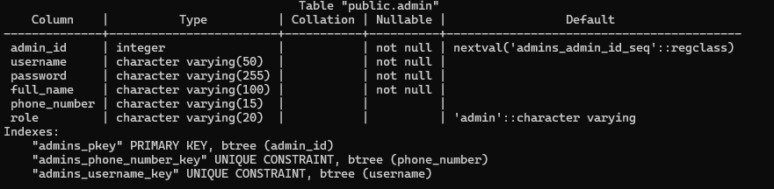

Member :  
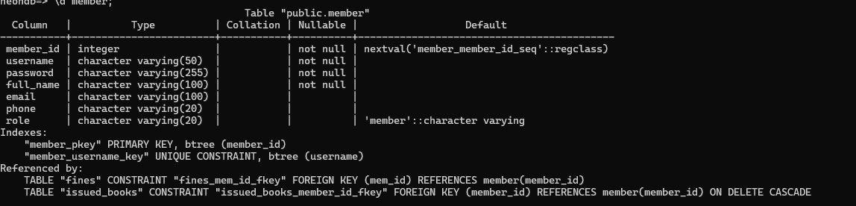

Book :   
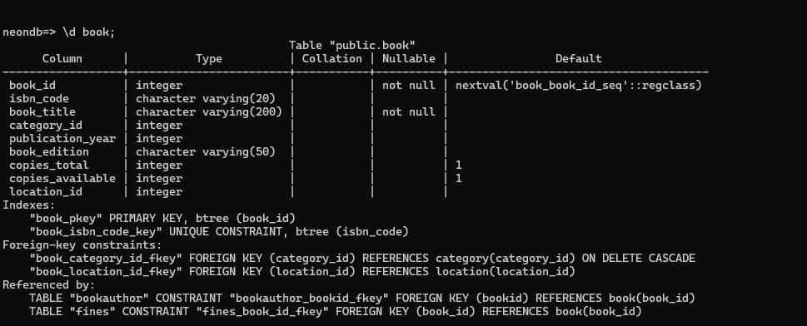

Issued_books   
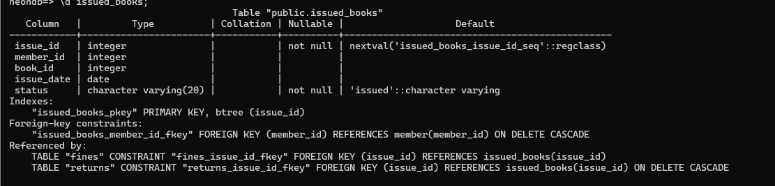

Returns:   
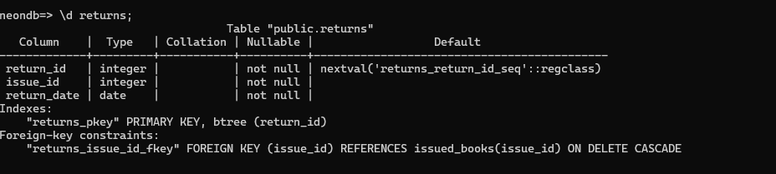

Location :   
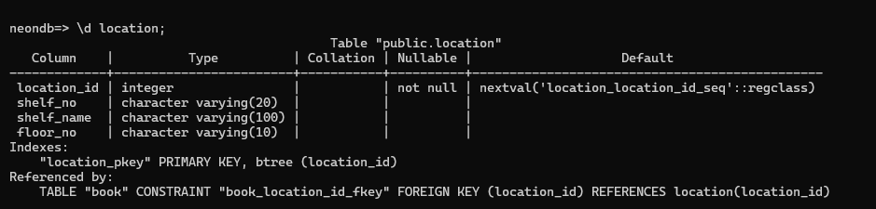

Fines :   
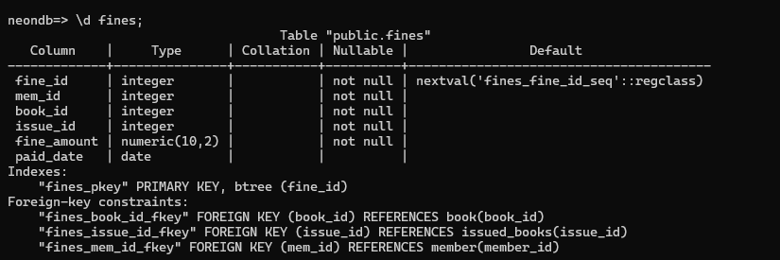

Category :

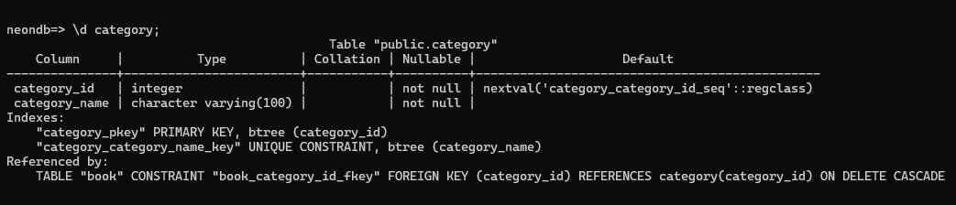

Bookauthor:   
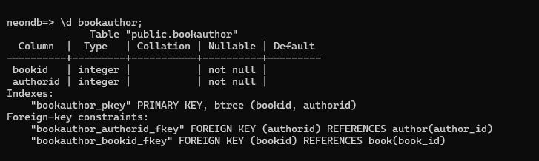

Author :   
